LabSheet 5

Hibernate Program using Annotation(Maven)

Problem Statement : Student mark processing using Hibernate with Maven

**Step 1: Create Maven Project (Eclipse)**

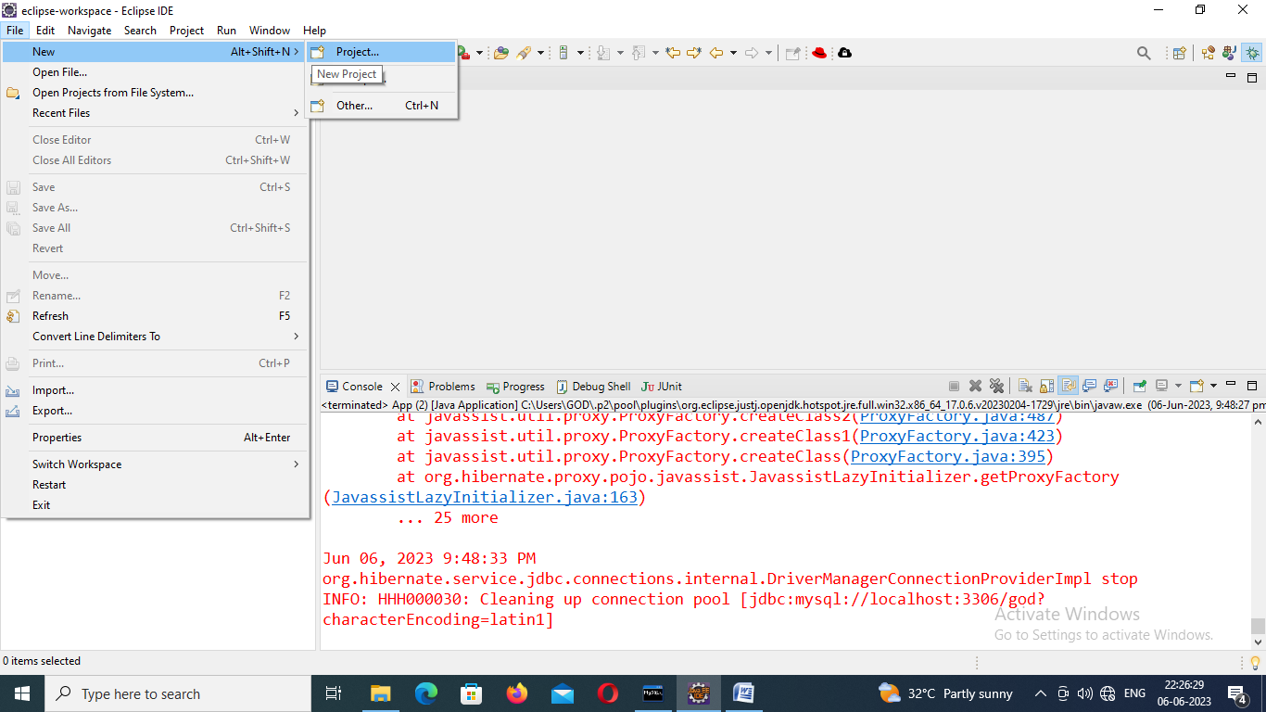

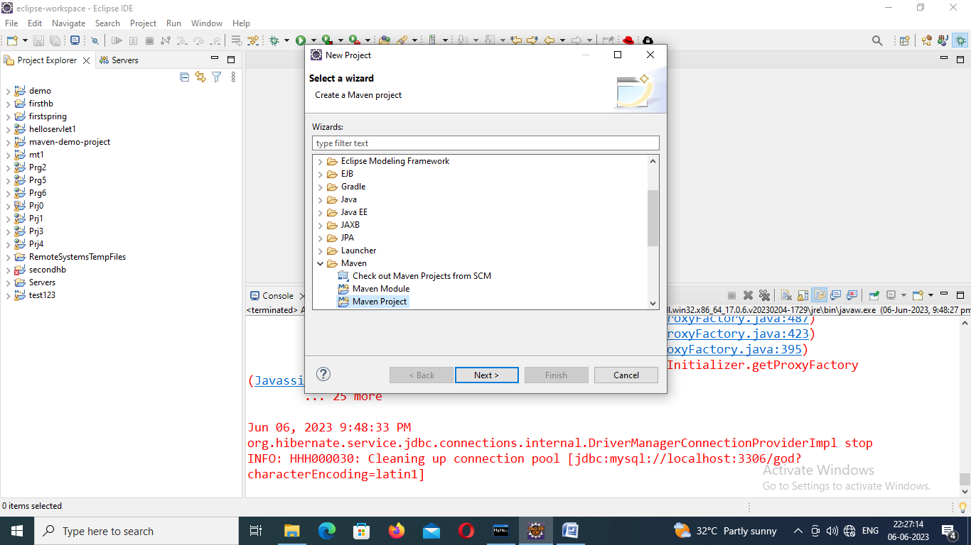

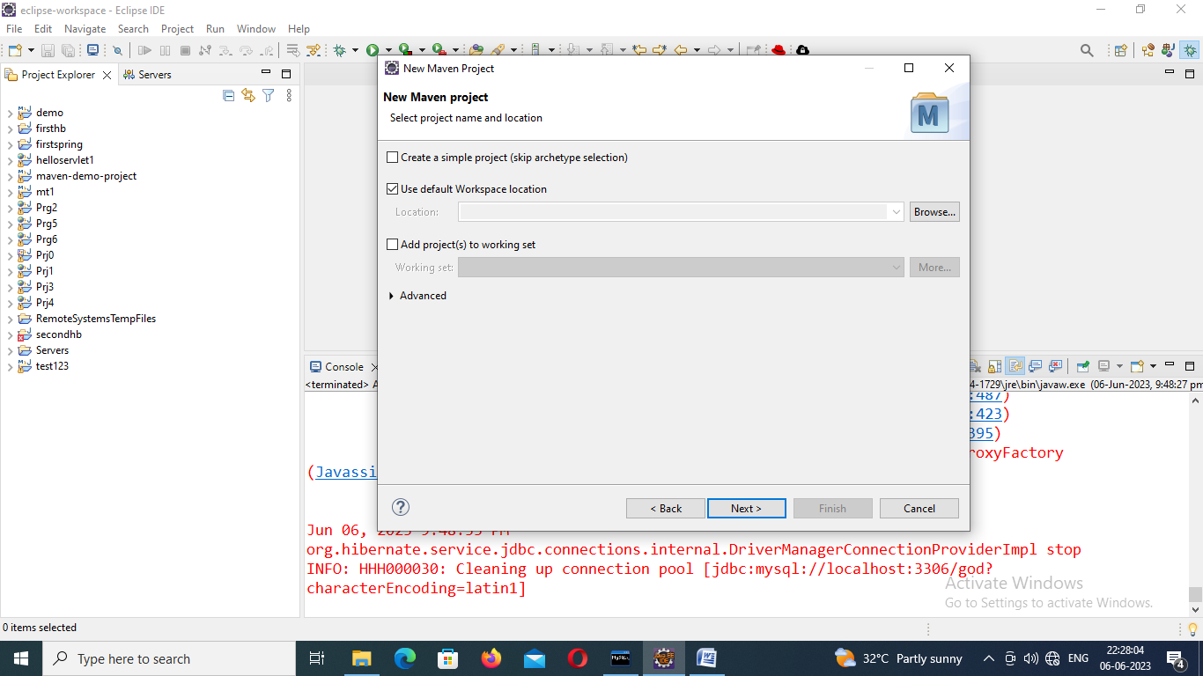

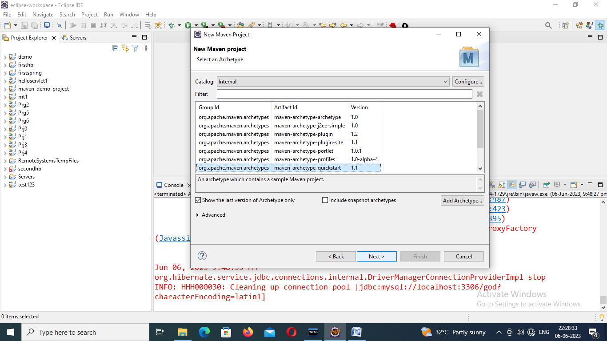

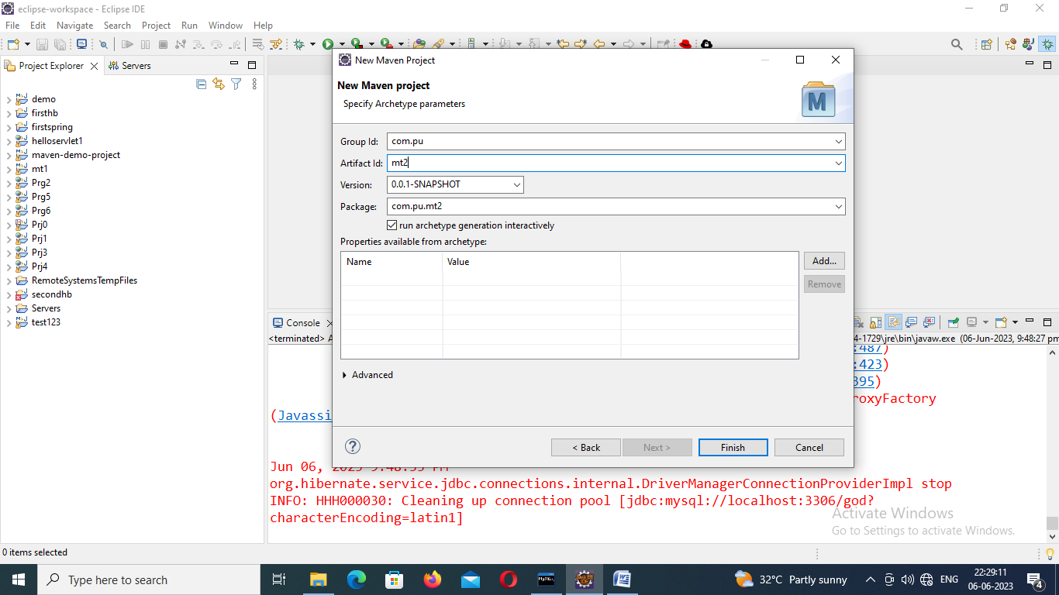

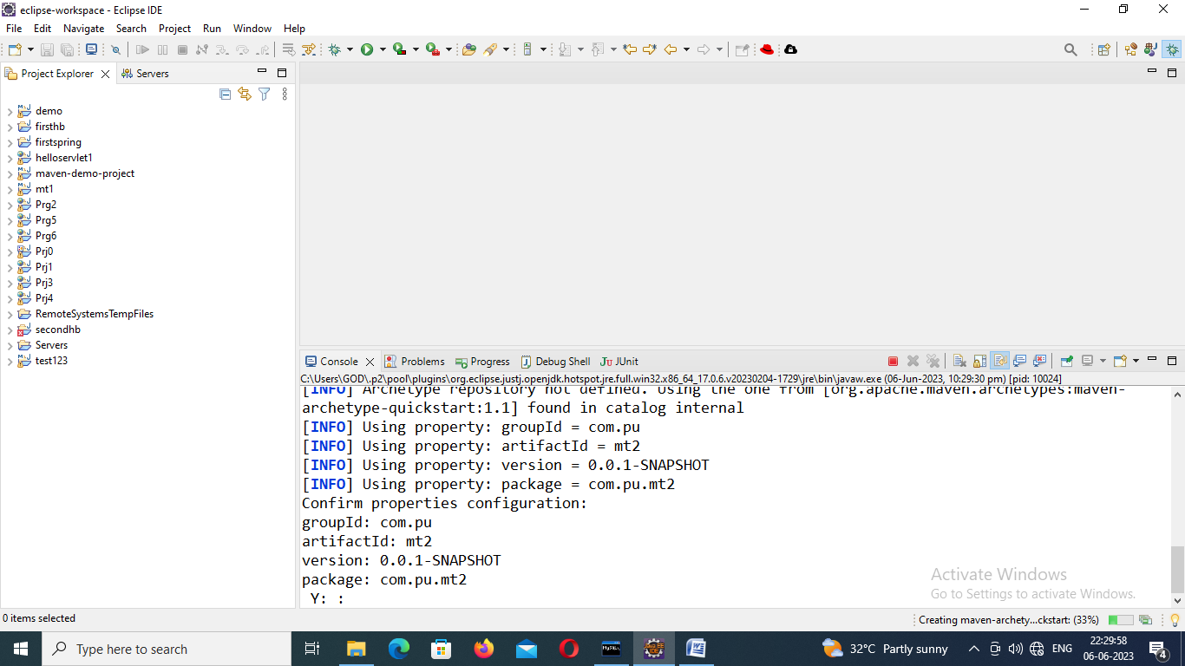

Step 2: Install JBoss Tools

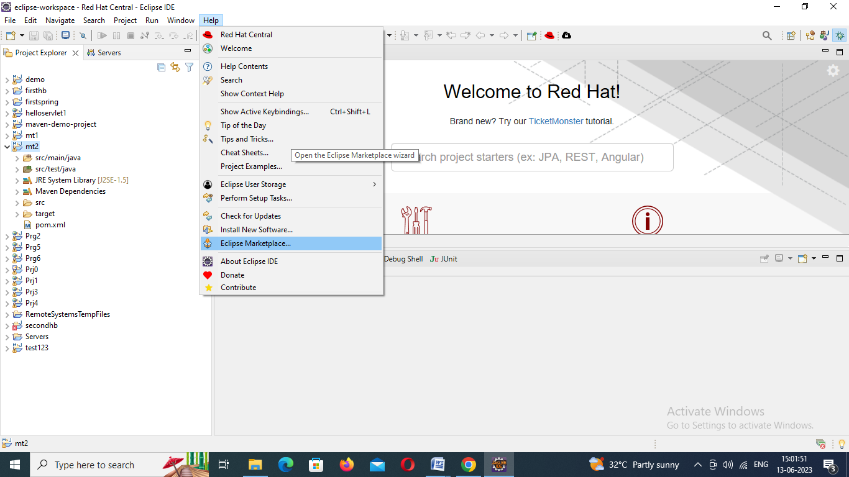

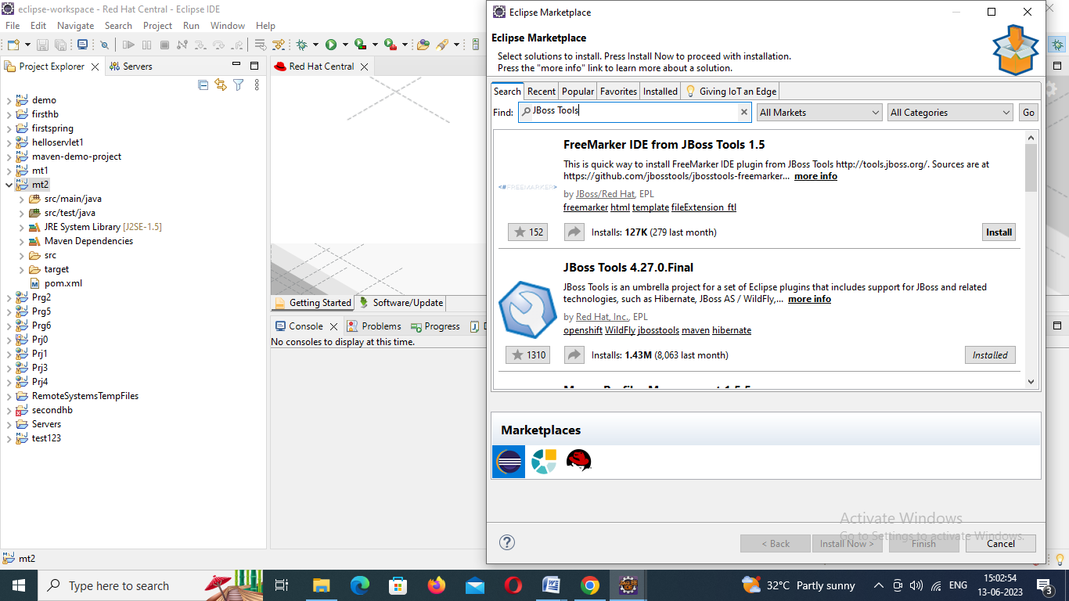

**Step 3: Add the dependency to the pom.xml file**

Include following dependencies available in mvnrepository.com in pom.xml file

1. Hibernate core 4.1.6
2. Mysqlconnector 8.0.32

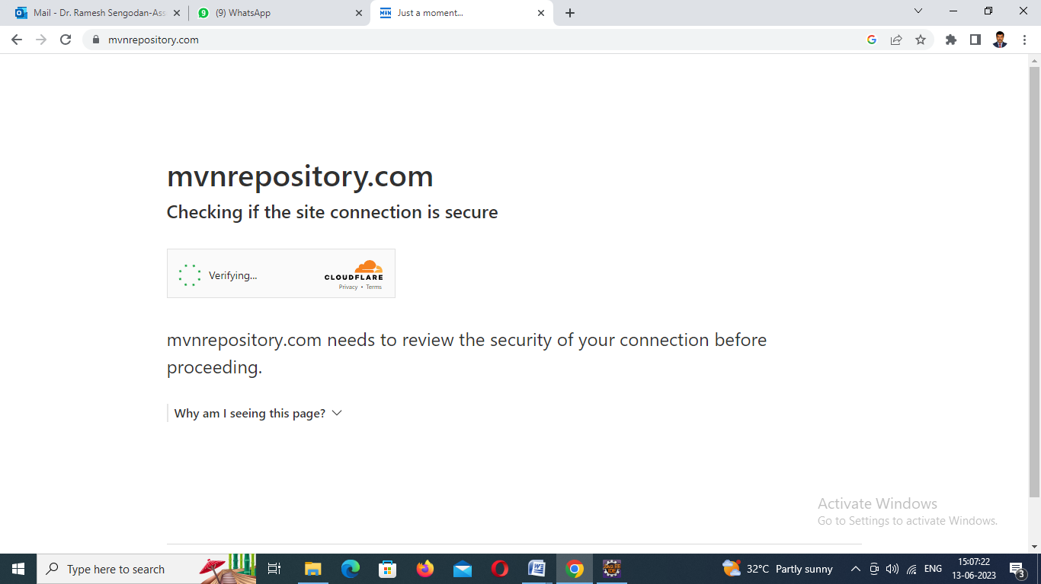

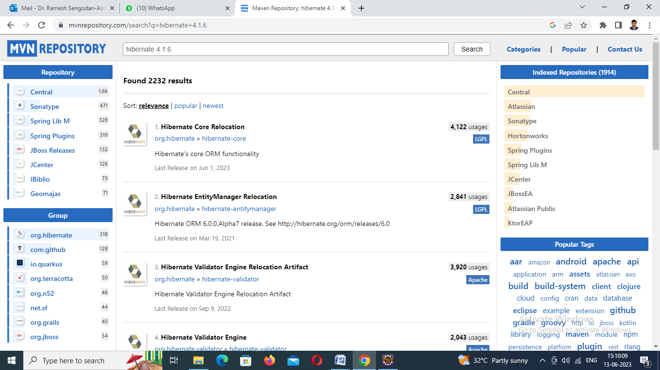

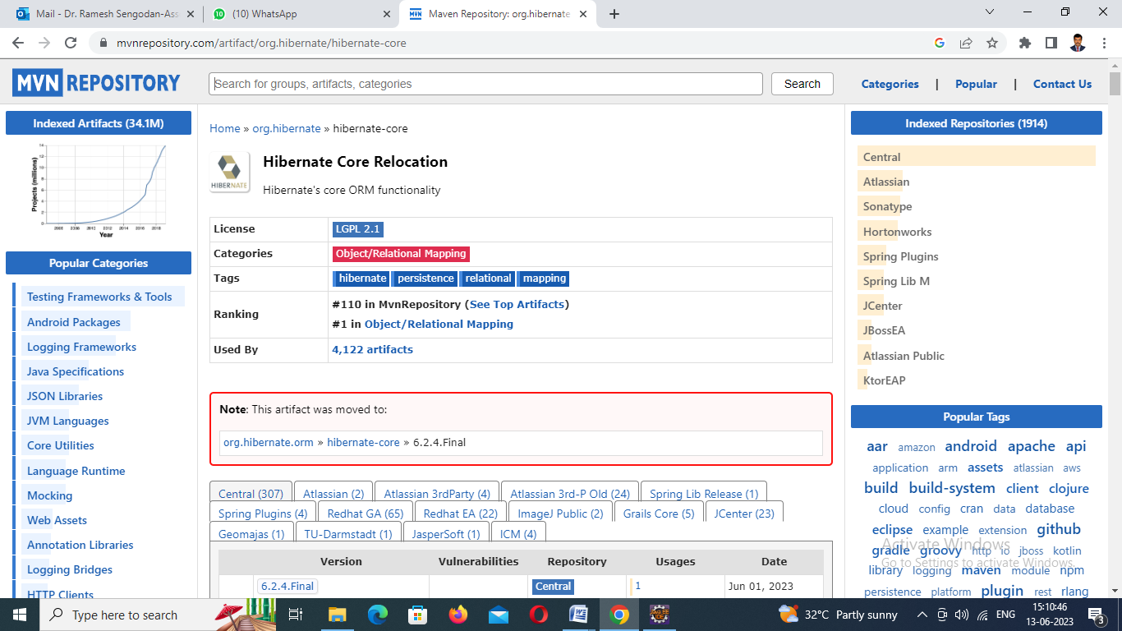

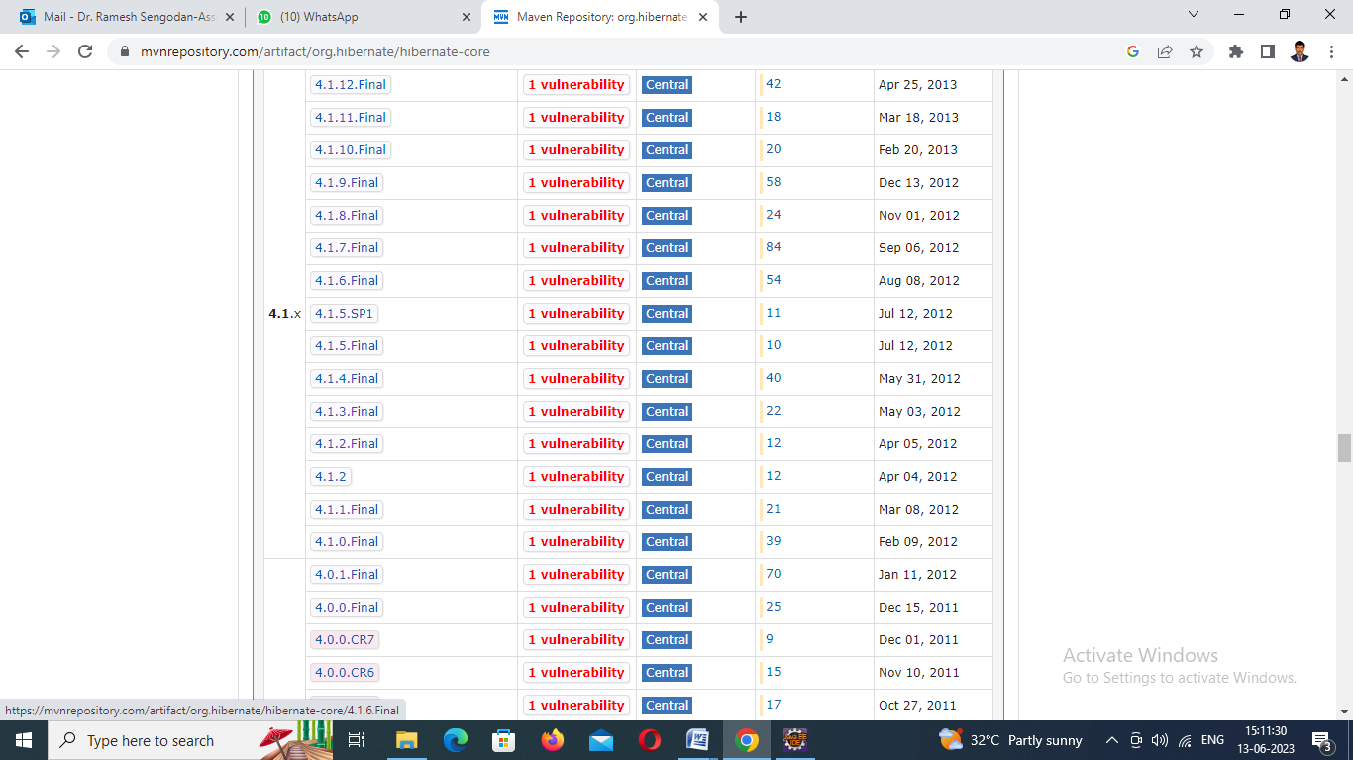

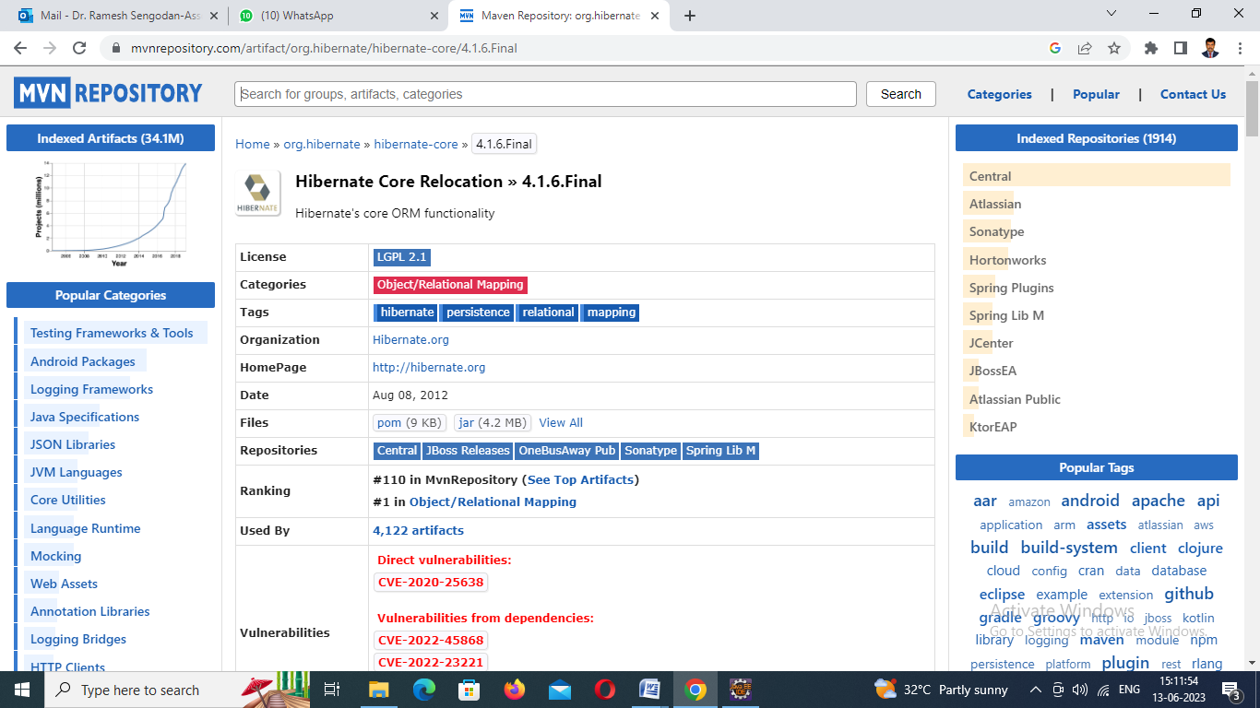

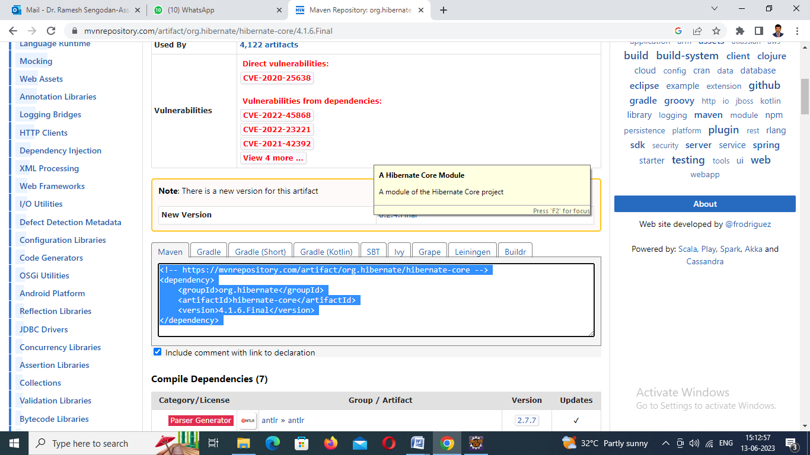

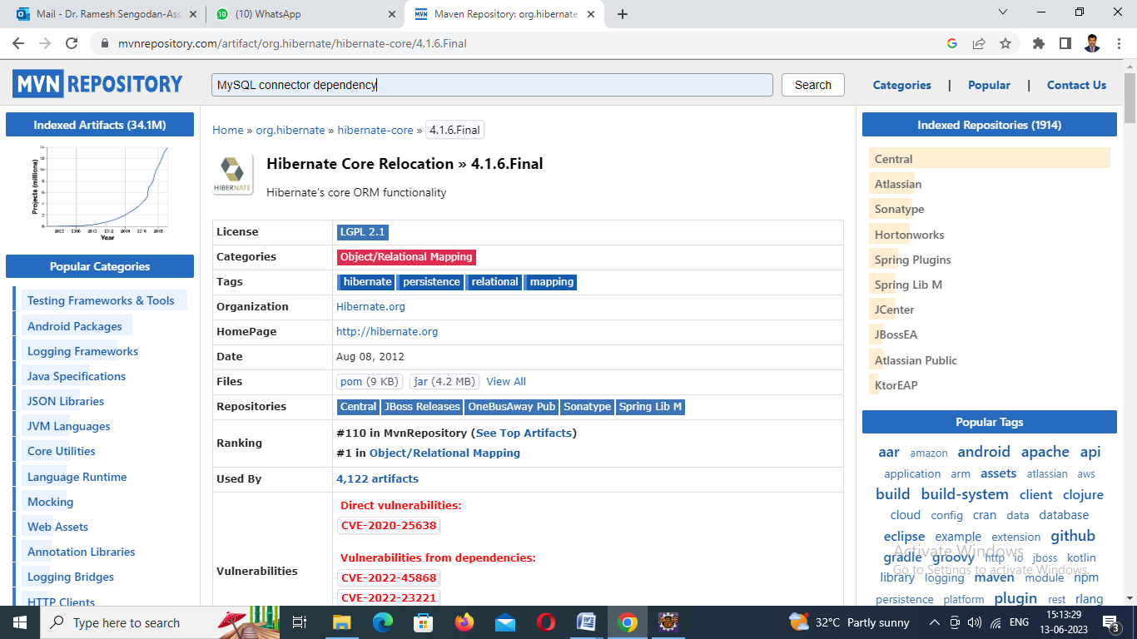

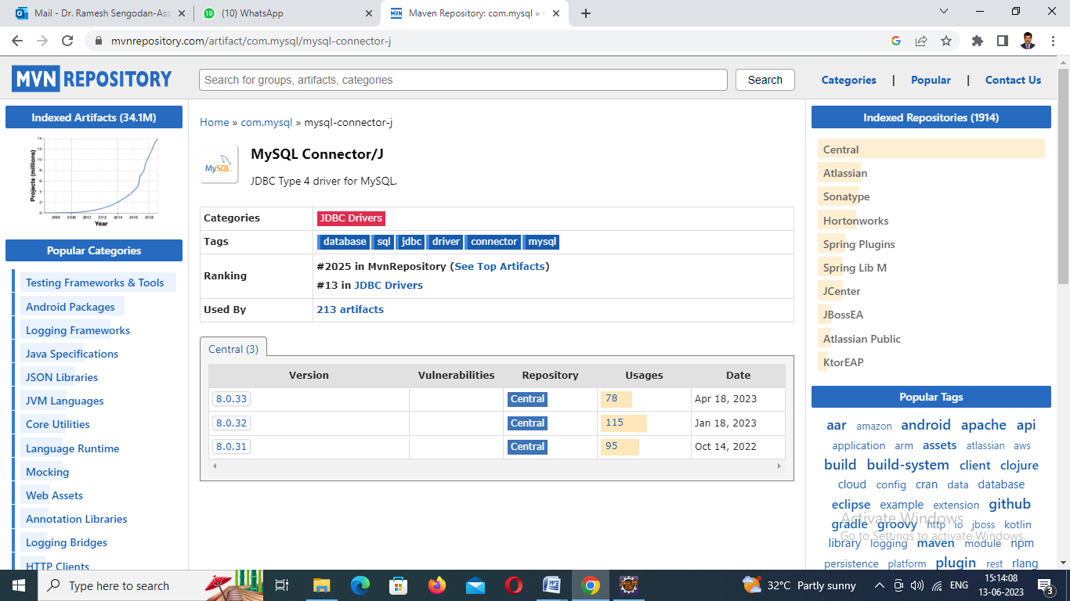

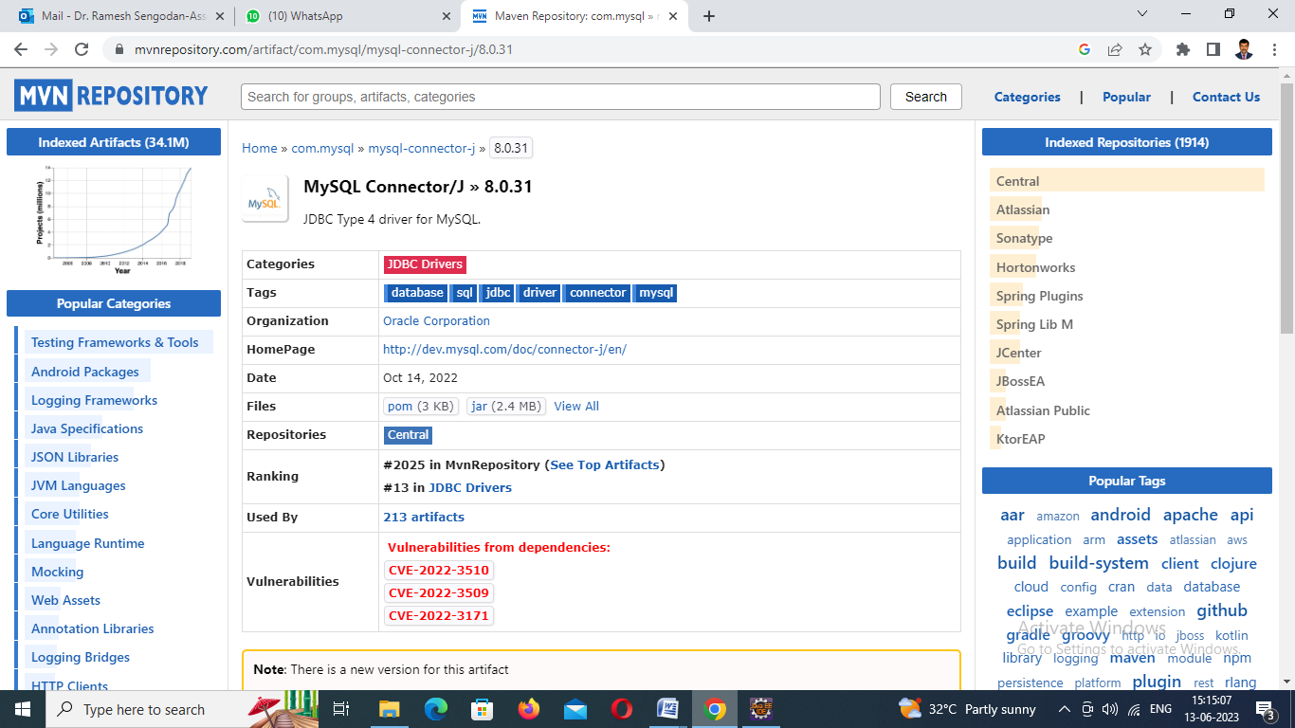

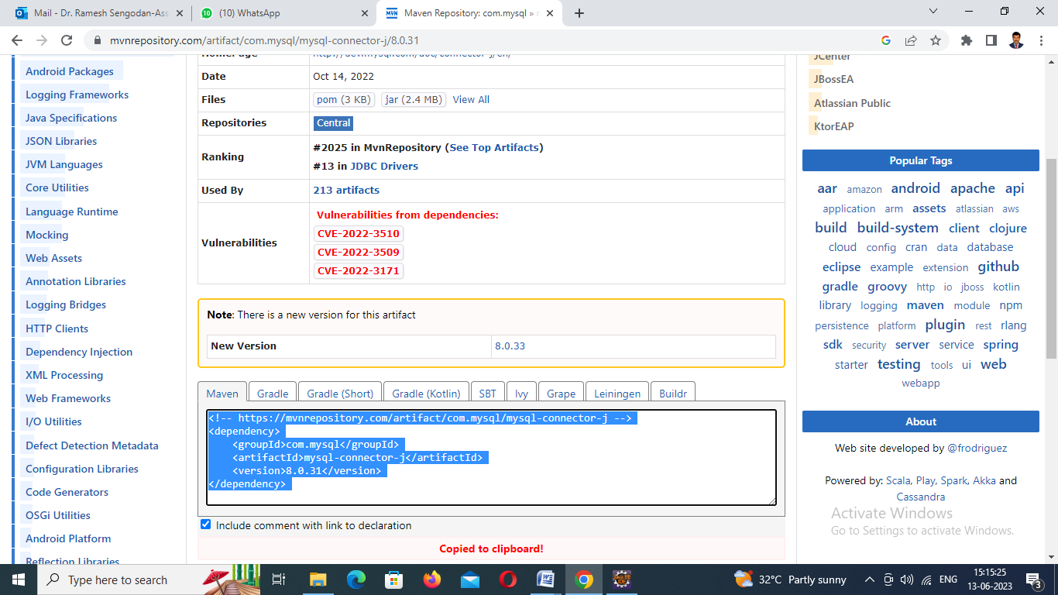

**pom.xml file**

* XML

|  |
| --- |
| <project xmlns="<http://maven.apache.org/POM/4.0.0>" xmlns:xsi="<http://www.w3.org/2001/XMLSchema-instance>"    xsi:schemaLocation="<http://maven.apache.org/POM/4.0.0> <http://maven.apache.org/xsd/maven-4.0.0.xsd>">    <modelVersion>4.0.0</modelVersion>      <groupId>com.spring.hibernate</groupId>    <artifactId>Spring-Hibernate</artifactId>    <version>0.0.1-SNAPSHOT</version>    <packaging>jar</packaging>      <name>Spring-Hibernate</name>    <url>[http://maven.apache.org](http://maven.apache.org/)</url>      <properties>      <project.build.sourceEncoding>UTF-8</project.build.sourceEncoding>    </properties>      <dependencies>      <dependency>        <groupId>junit</groupId>        <artifactId>junit</artifactId>        <version>3.8.1</version>        <scope>test</scope>      </dependency>        <!-- <https://mvnrepository.com/artifact/org.hibernate/hibernate-core> -->      <dependency>      <groupId>org.hibernate</groupId>      <artifactId>hibernate-core</artifactId>      <version>5.6.14.Final</version>      </dependency>        <!-- <https://mvnrepository.com/artifact/com.mysql/mysql-connector-j> -->      <dependency>      <groupId>com.mysql</groupId>      <artifactId>mysql-connector-j</artifactId>      <version>8.0.31</version>      </dependency>    </dependencies>  </project> |

**Step 4: Add POJO and main classes for working with the functionality**To create a POJO(Module) class file.

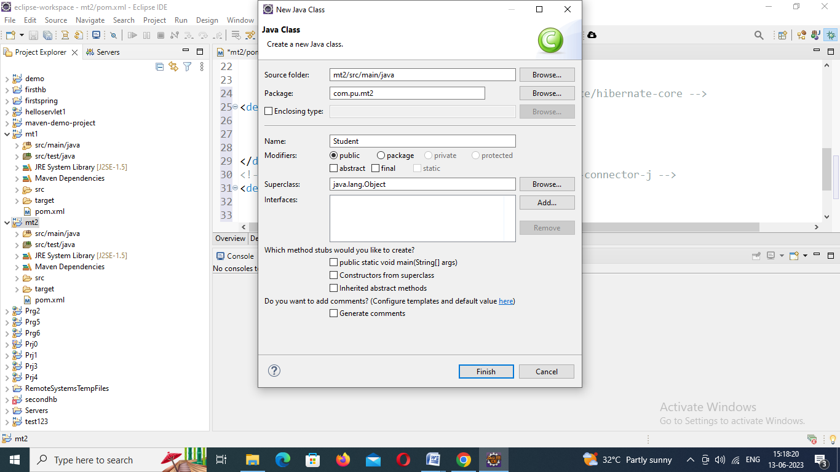

Student.java

**package** com.pu.test123;

**import** javax.persistence.Entity;

**import** javax.persistence.Id;

@Entity

**public** **class** Student {

@Id

**private** **int** roll;

**private** String name;

**private** **int** marks;

**public** **int** getRoll() {

**return** roll;

}

**public** **void** setRoll(**int** roll) {

**this**.roll = roll;

}

**public** String getName() {

**return** name;

}

**public** **void** setName(String name) {

**this**.name = name;

}

**public** **int** getMarks() {

**return** marks;

}

**public** **void** setMarks(**int** marks) {

**this**.marks = marks;

}

}

Step 5: **Step 3: Add hibernate.cfg.xml file for database parameters**To create hibernate configuration file

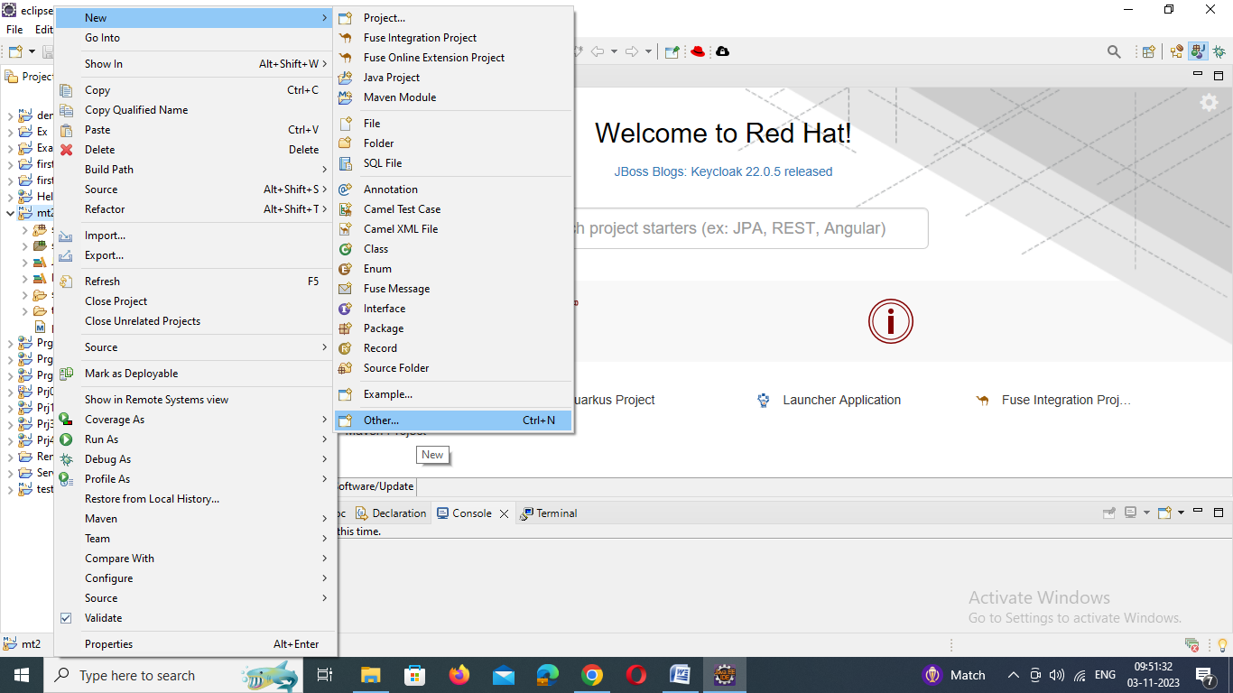

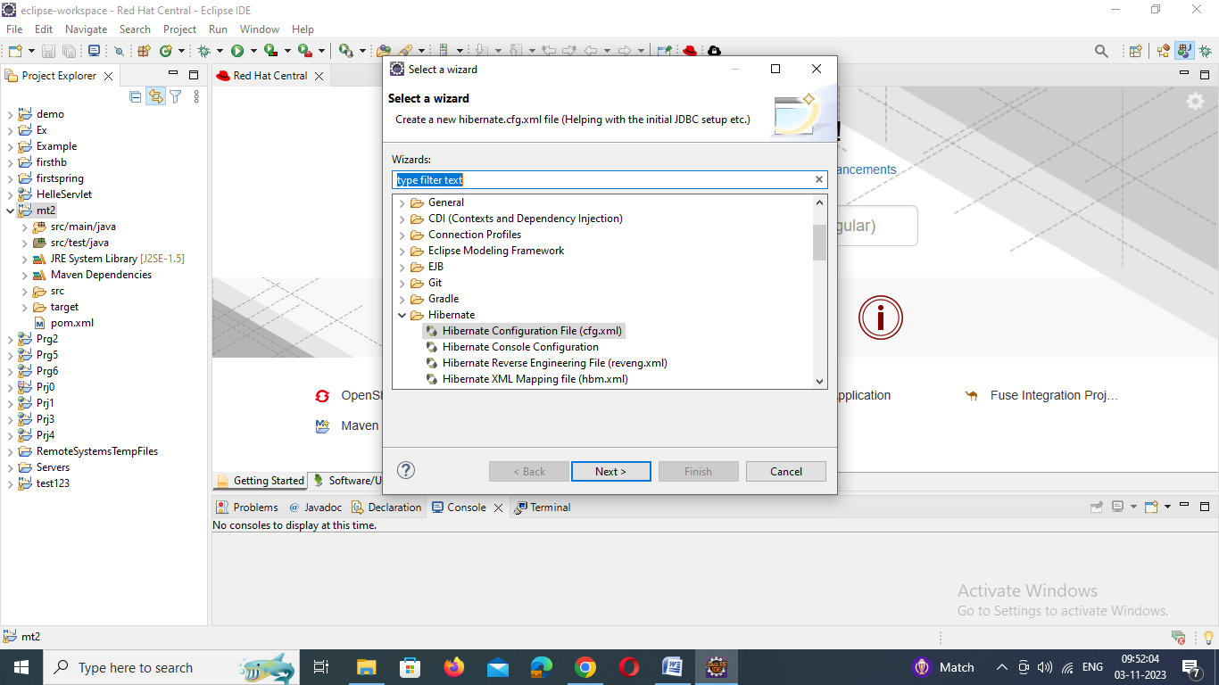

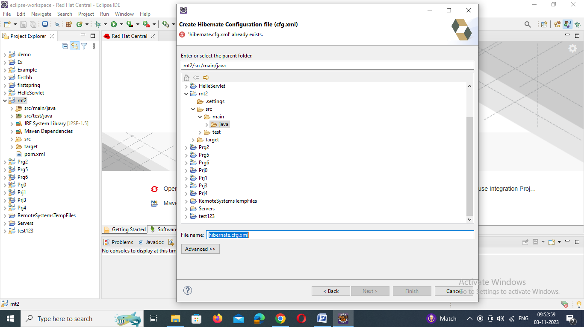

# 4. MySQL Database Setup

Let's create a database named "demo" in MySQL:

CREATE DATABASE 'demo';

**Note:**Hibernate will create **Student**tables automatically

Create table Student(roll int,name varchar(30),marks int);

Hibernate.cfg.xml

<?xml version=*"1.0"* encoding=*"utf-8"*?>

<!DOCTYPE hibernate-configuration PUBLIC

"-//Hibernate/Hibernate Configuration DTD 3.0//EN"

"http://www.hibernate.org/dtd/hibernate-configuration-3.0.dtd">

<hibernate-configuration>

<session-factory>

<property name=*"hibernate.connection.driver_class"*>com.mysql.jdbc.Driver</property>

<property name=*"hibernate.connection.url"*>jdbc:mysql://localhost:3306/god?characterEncoding=latin1</property>

<property name=*"hibernate.connection.username"*>root</property>

<property name=*"hibernate.connection.password"*>admin123</property>

<property name=*"hibernate.dialect"*>org.hibernate.dialect.MySQLDialect</property>

<property name=*"show_sql"*>true</property>

<property name=*"format_sql"*>true</property>

<property name=*"hbm2ddl.auto"*>update </property>

<mapping resource=*"com.pu.student.hbm.xml"* />

</session-factory>

</hibernate-configuration>

Open App file and edit

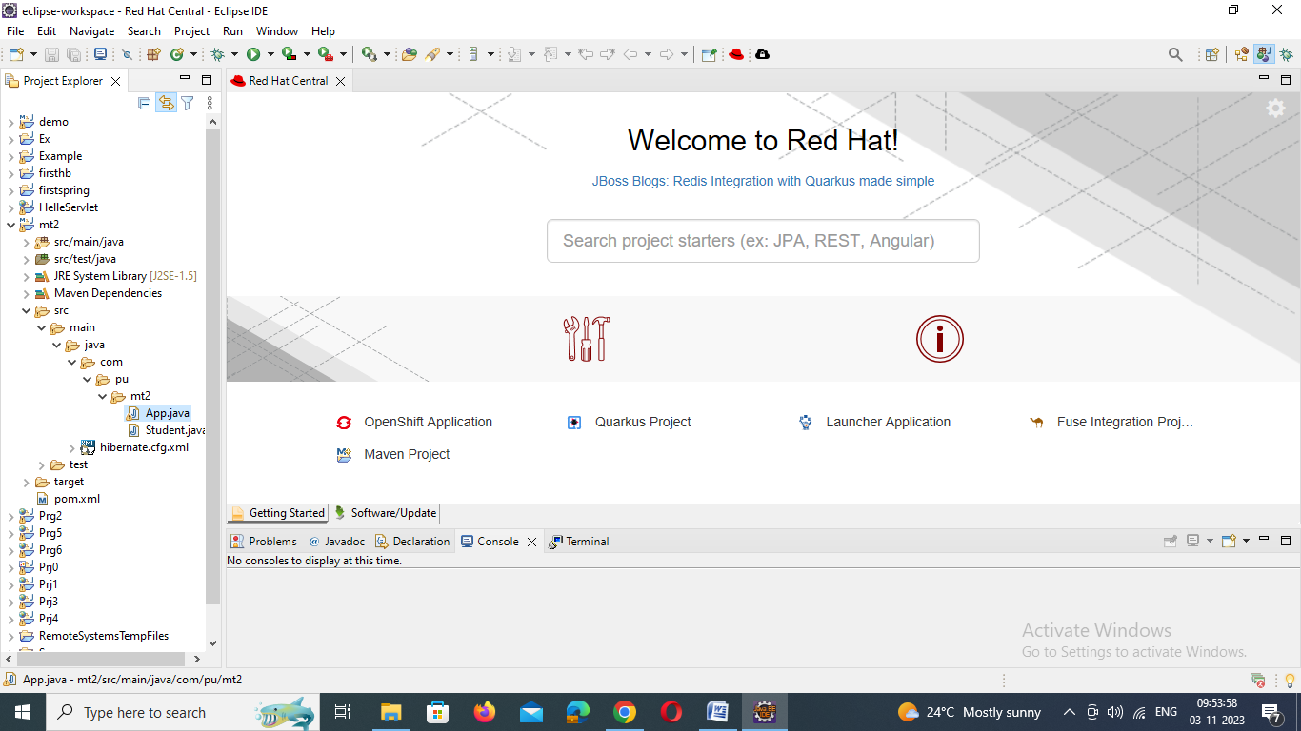

App.java

**package** com.pu.test123;

**import** org.hibernate.Session;

**import** org.hibernate.SessionFactory;

**import** org.hibernate.Transaction;

**import** org.hibernate.cfg.Configuration;

/**

* Hello world!

*

*/

**public** **class** App

{

**public** **static** **void** main( String[] args )

{

Student student = **new** Student();

student.setRoll(1);

student.setName("god");

student.setMarks(100);

//1. create Configuration object

Configuration configuration=**new** Configuration().configure().addAnnotatedClass(Student.**class**);

//2. create Session Factroy object

SessionFactory sessionFactory=configuration.~~buildSessionFactory~~();

//3. Create Session object

Session session=sessionFactory.openSession();

//4. Begin your transaction

Transaction transaction=session.beginTransaction();

//5.Save your object to database

session.save(student);

//6/ Commit your transaction

transaction.commit();

session.close();

sessionFactory.close();

}

}